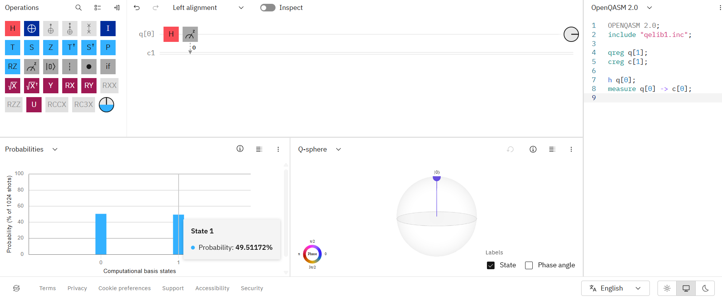
Section 4: OPENQASM 2.0 Program for Single Qubit and Single Classical Bit
OPENQASM 2.0;
include "qelib1.inc";
qreg q[1];
creg c[1];
h q[0];
measure q[0] -> c[0];

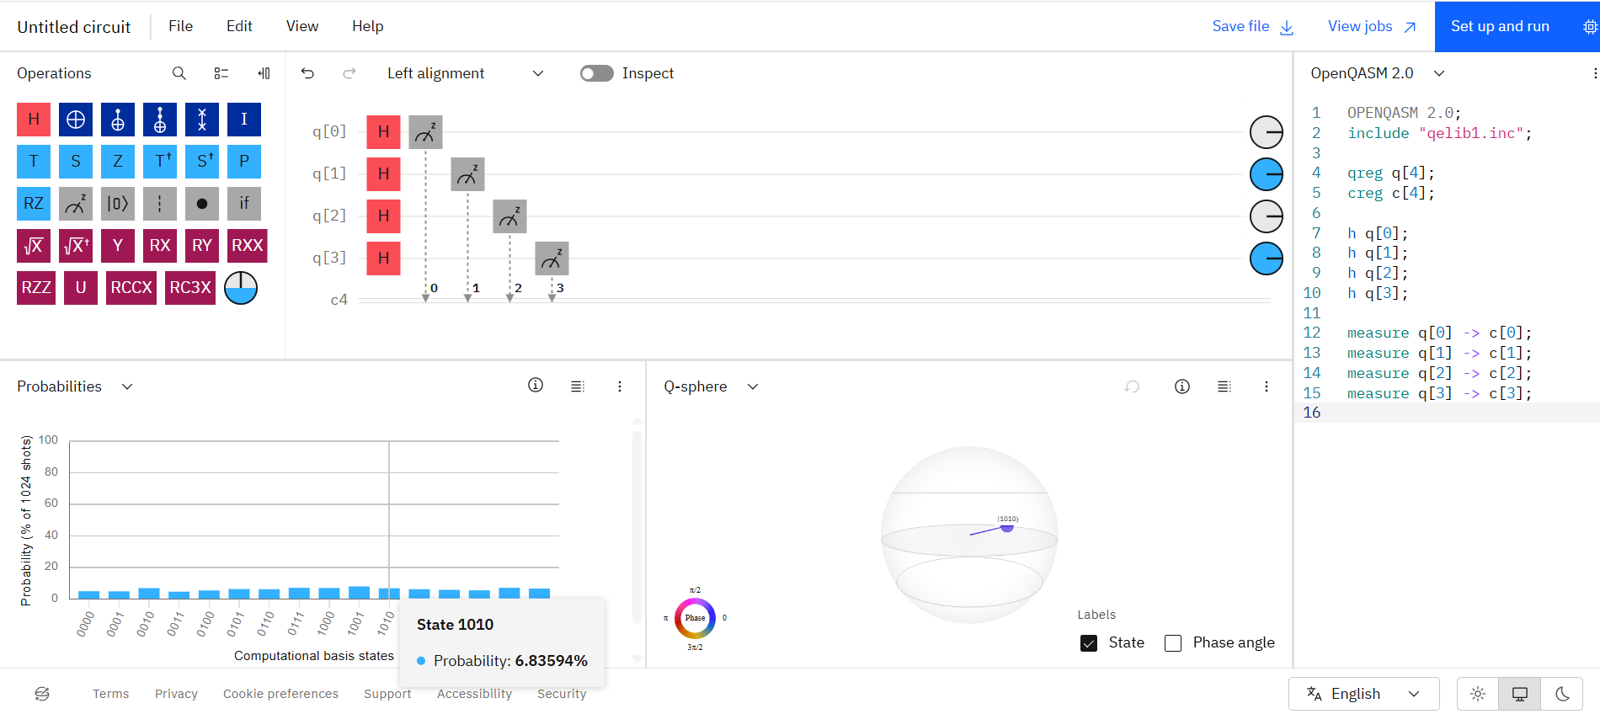
Section 4(ii): OPENQASM 2.0 Program for Four Qubits and Four Classical Bits.
OPENQASM 2.0;
include "qelib1.inc";
qreg q[4];
creg c[4];
h q[0];
h q[1];
h q[2];
h q[3];
measure q[0] -> c[0];
measure q[1] -> c[1];
measure q[2] -> c[2];
measure q[3] -> c[3];

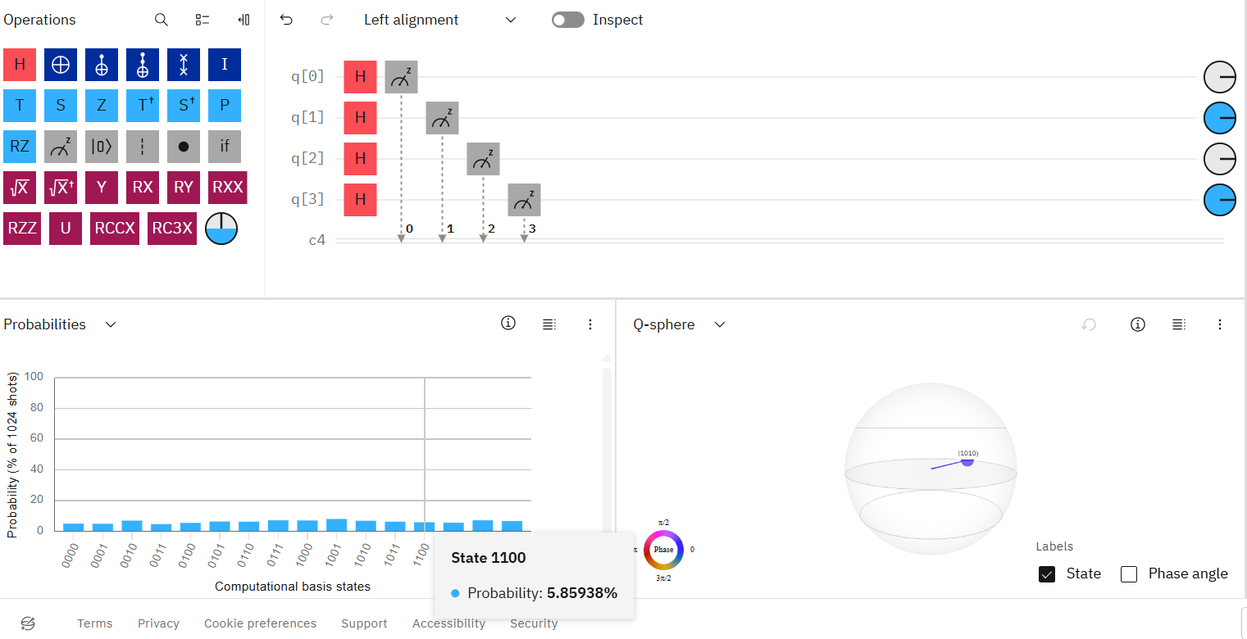
Section 5 : Hadamard gate to four qubits.

